Debugging Report – Debugging Exercise
Student: Jeff Aries
Date: February 1, 2026

1. Problem Summary
The program crashed when calculating a discount because one product price was stored as a string ("500") instead of a number.

2. Bug Identification
- Ran the program in PyCharm and reproduced the error.
- Set a breakpoint at calculate_discount(price, discount_rate).
- Stepped through the loop until the Tablet product.
- Observed price = "500" (type str) in the debugger.
- Stepping into the function caused a TypeError at price * discount_rate.
Screenshot: Breakpoint showing price = "500" before the error occurs.

3. Root Cause
The program assumed all prices were numeric, but the product list contained a string value.

4. Fix Applied
- Converted prices to floats and validated discount rates.
- Added error handling so invalid items do not stop execution.

5. Testing
The program now runs successfully and reports errors for invalid inputs without crashing.
6. Screenshots
- Observed price = "500" (type str) in the debugger. (ref. Bug Identification, bullet 4)
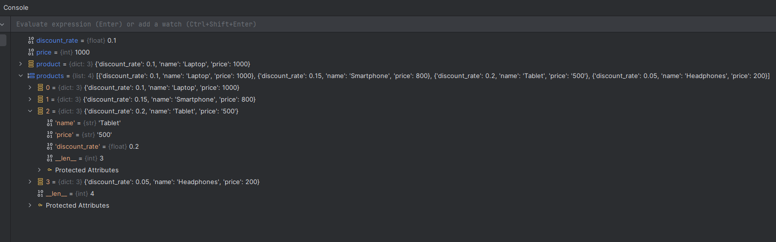
- Successful Program Run
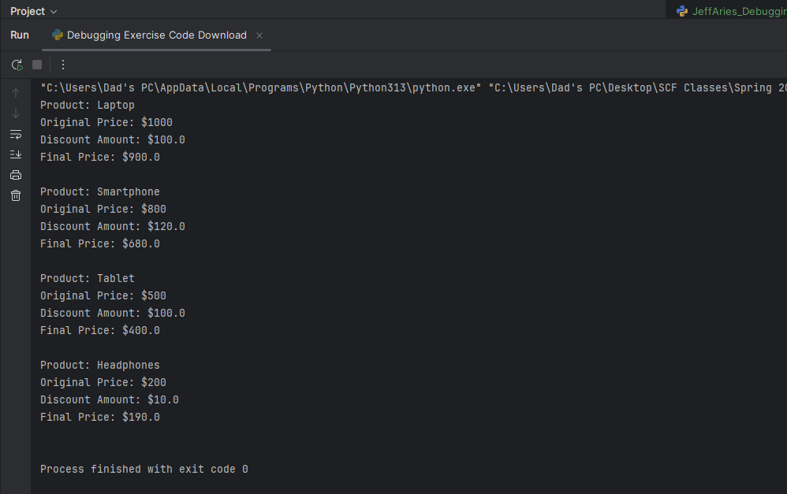
7. Repository Link
- https://github.com/MagikTTV/ProgrammingConcepts2/tree/master/Debugging%20Exercise

